**Name: vijay Vishnu p b**

**Roll No: 49**

**Batch: B**

**Date: 01-04-2022**

**ADVANCED DBMS LAB**

**EXPERIMENT NO.: 2**

**AIM**

To familiarize with selecting data from single table.

**QUESTION**

1. **List all data from table deposit.**

SELECT * FROM deposit;

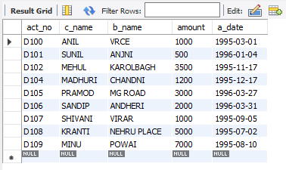

1. **List all data from borrow.**

SELECT * FROM borrow;

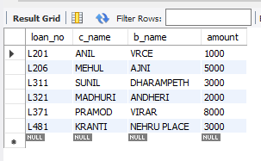

1. **List all data from customer.**

SELECT * FROM customer**;**

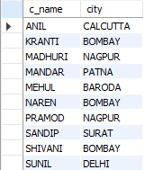

1. **List all data from branch.**

SELECT * FROM branch;

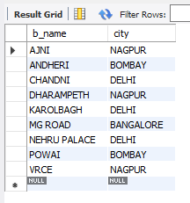

1. **Give account no and amount of deposit.**

SELECT act_no, amount FROM deposit;

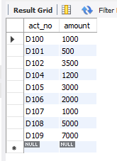

1. **Give customer name and account no of depositors.**

SELECT c_name, act_no FROM deposit;

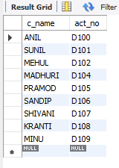

1. **Give name of customers.**

SELECT c_name FROM customer;

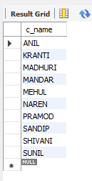

1. **Give name of branches.**

SELECT b_name FROM branch;

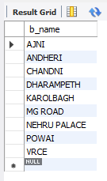

1. **Give name of borrows.**

SELECT c_name FROM borrow;

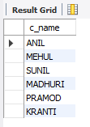

1. **Give names of customer living in city Nagpur.**

SELECT c_name FROM customer WHERE city='NAGPUR';

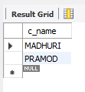

1. **Give names of depositors having amount greater than 4000.**

SELECT c_name FROM deposit WHERE amount>4000;

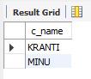

1. **Give account date of Anil.**

SELECT a_date FROM deposit WHERE c_name='ANIL';

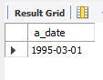

1. **Give name of all branches located in Bombay.**

SELECT b_name FROM branch WHERE city='BOMBAY';

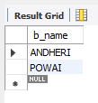

1. **Give name of borrower having loan number L205.**

SELECT c_name FROM borrow WHERE loan_no='L205';

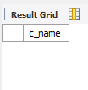

1. **Give names of depositors having account at VRCE.**

SELECT c_name FROM deposit WHERE b_name='VRCE';

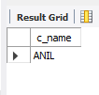

1. **Give names of all branched located in city Delhi.**

SELECT b_name FROM branch WHERE city='DELHI';

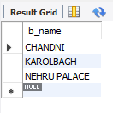

1. **Give name of the customers who opened account date ‘1-12-96’.**

SELECT c_name FROM deposit WHERE a_date='1996-12-01';

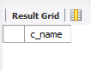

1. **Give account no and deposit amount of customers having account opened between dates  ‘1-12-96’ and ‘1-5-96’.**

SELECT act_no, amount FROM deposit WHERE a_date BETWEEN '1996-12-01' AND '1996-05-01';

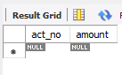

1. **Give name of the city where branch KAROLBAGH is located.**

SELECT city FROM branch WHERE b_name='KAROLBAGH';

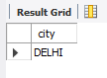

1. **Give details of customer ANIL.**

SELECT * FROM customer JOIN borrow ON customer.c_name=borrow.c_name JOIN deposit ON deposit.c_name=borrow.c_name WHERE customer.c_name='ANIL';

